Spark internal

# Spark SQL vs Dataframe API

#### Performance

Whether you write the code using DataFrame API or Spark Sql API , there is no significant difference in terms of performance because both the dataframe api and spark sql api are abstractions on top of RDD (Resilient Distributed Dataset).

#### Error at compile vs runtime

In your Spark SQL string queries, you won't know a syntax error until runtime (which could be costly), whereas in DataFrames syntax errors can be caught at compile time.

#### Spark API has more control of memory and CPU usage than Spark SQL

The main advantage of dataframe api is that you can use dataframe optimized functions, for example : cache() , in general you will have more control of the execution plan.

# 1.Architecture

* Driver != cluster managerやで
  + Driverも一つのnode managerによってmanageされる。
* Executorってのはprocessのことやから、node managerがいくつものexecutorをrunする。

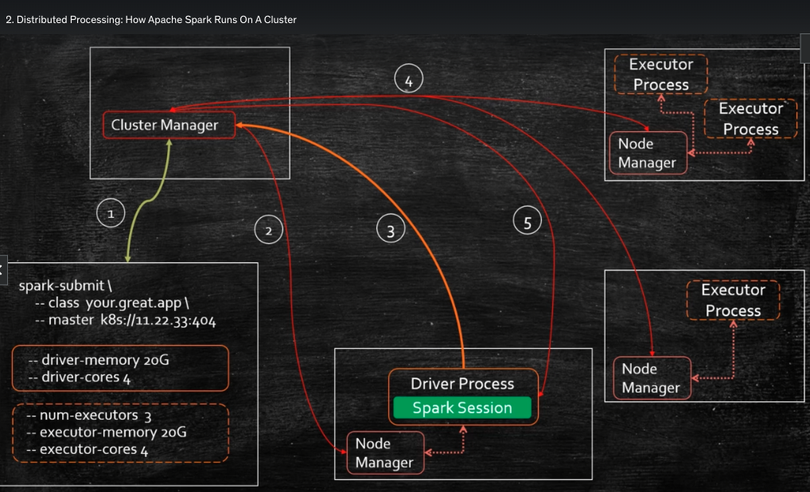

* Driver is responsible for
  + 1. the resource management,
  + 2.dynamically increase/decrease resource consumption
  + 3.distribute and schedule work across executor processes.
  + 4.Reacts to failures.
  + 5.Monitors progress
* Executor is responsible for
  + 1.executor tasks
  + 2.report to the driver.

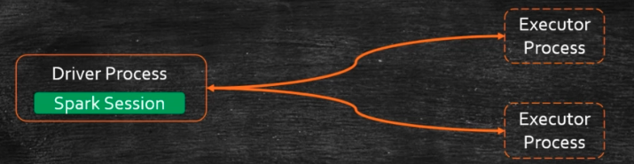

## Cluster manager: for driver and executors

Somewhat confusingly, a cluster manager will have its own “driver” (sometimes called master) and “worker” abstractions. The core difference is that these are tied to physical machines rather than processes.

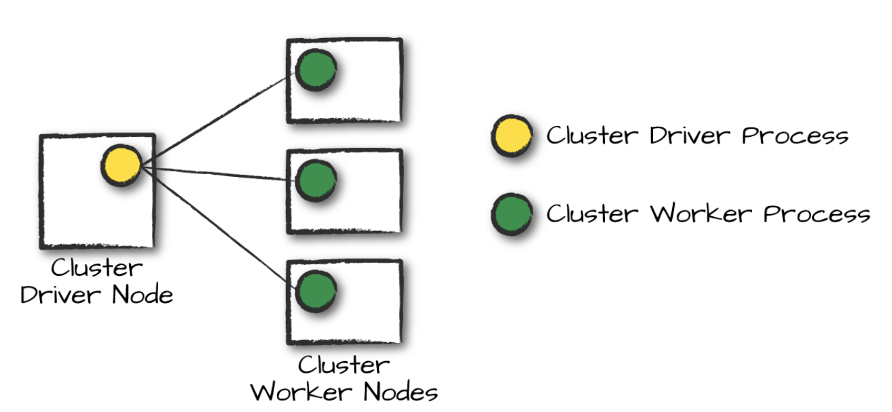

## Stage in Spark

* Each stage does write exchange for the next stage, and this creates a shuffling.
* One thing to remember, action can occur in the executor as well.

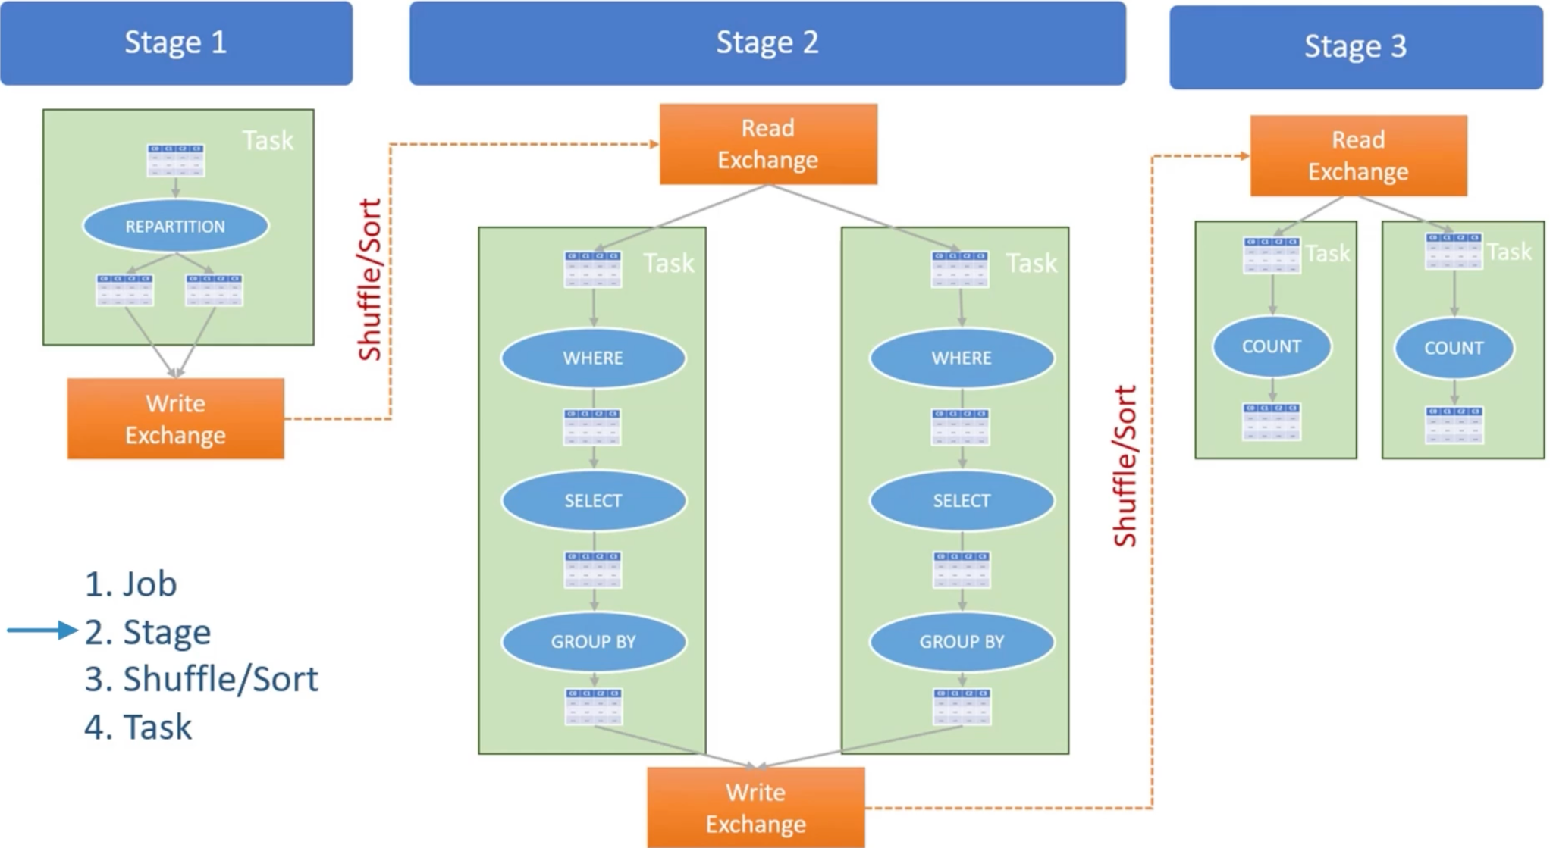

### Why does each stage have a write exchange?

This is because for all shuffle operations, Spark writes the data to stable storage (e.g., disk), and can reuse it across multiple jobs. .

## Executor architecture

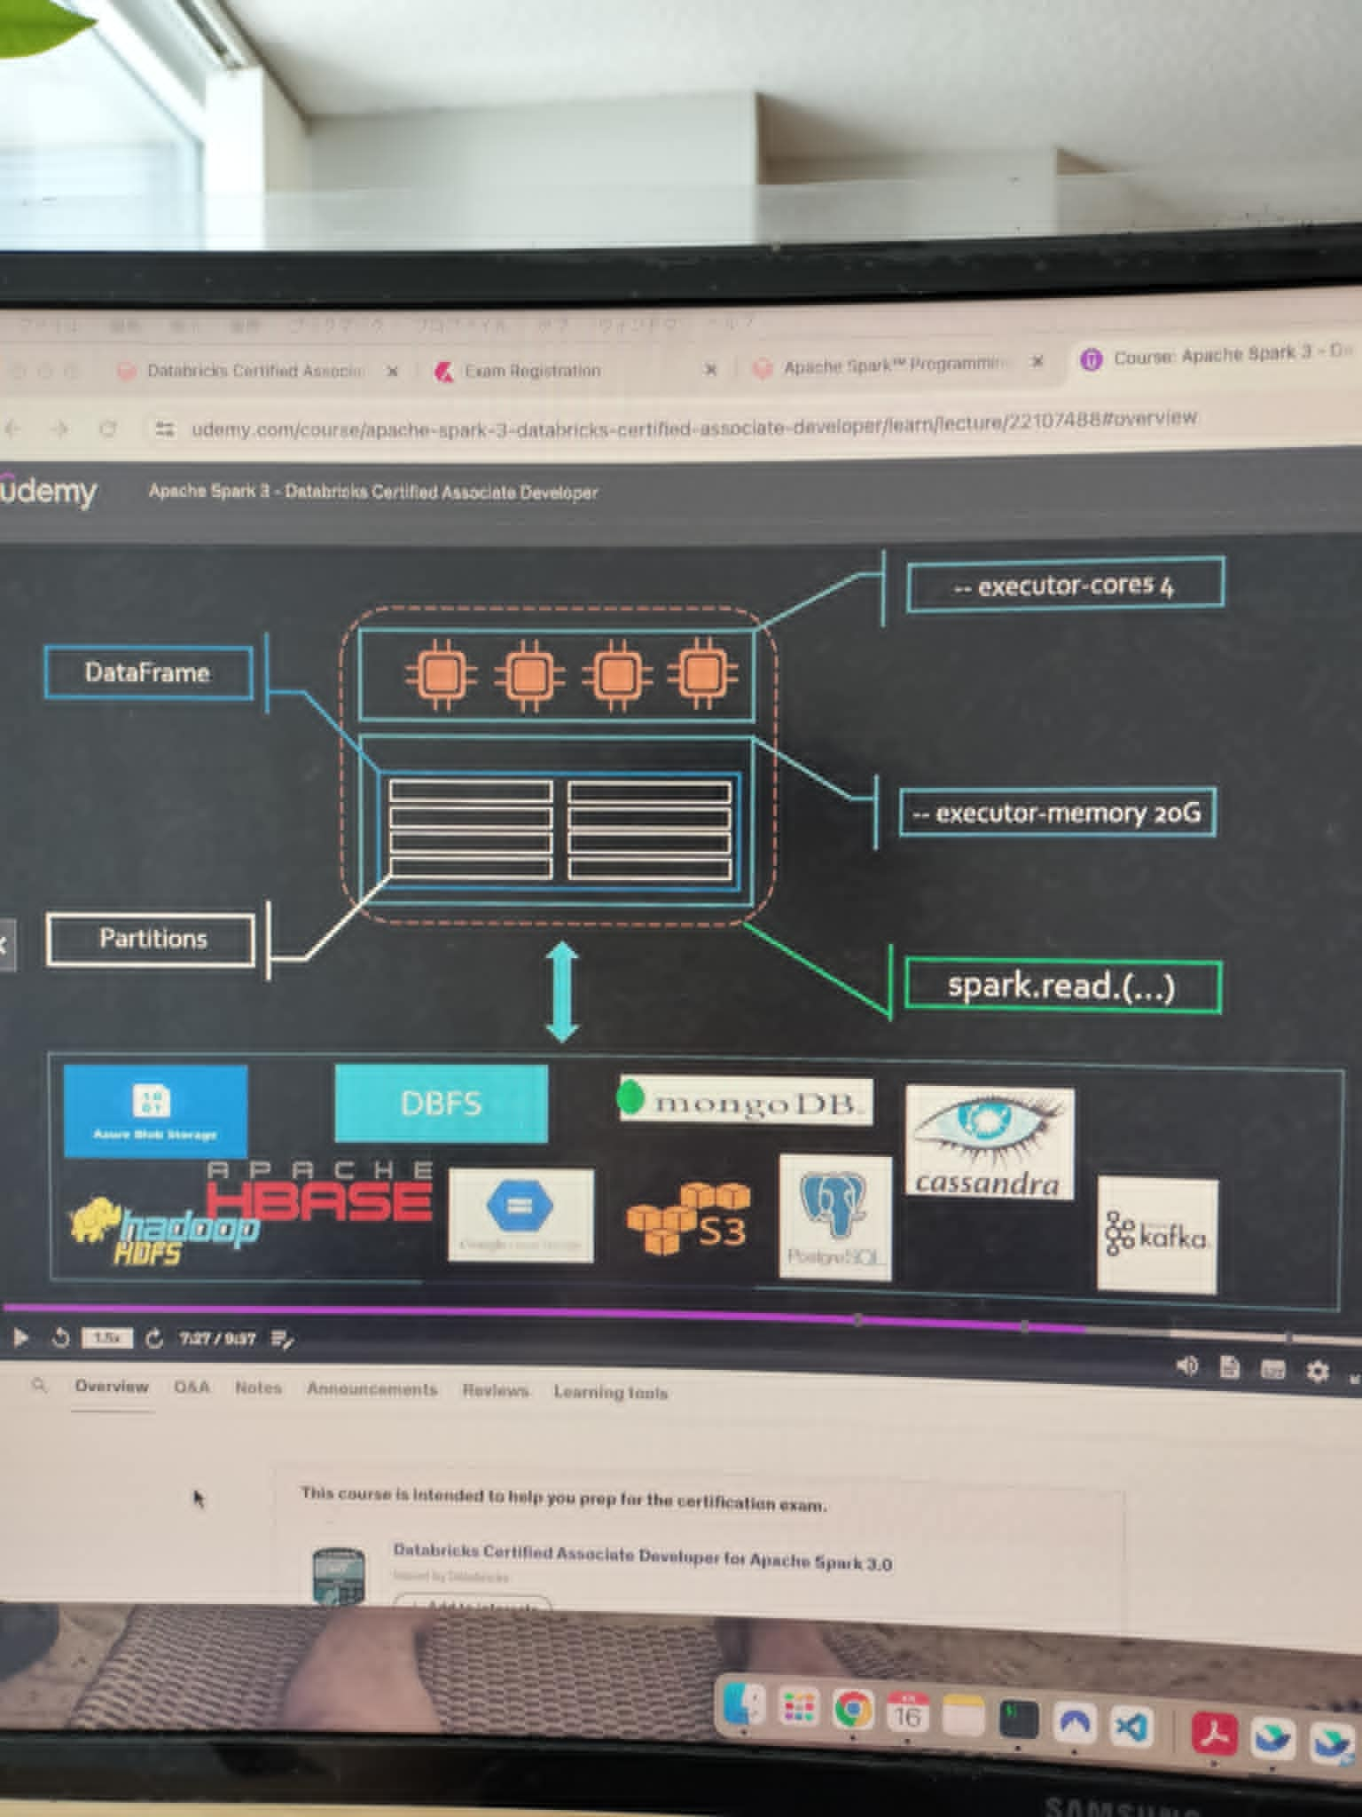

## 

## 

# 2.Core Concept

## 

## 

### Dataframe architecture in executor

Everytime you run a function/transformation, the executor creates a new dataframe. Why?

This is because

* dataframe is an immutable object.
* Dataframe is distributed across multiple executors.

ちなみに

You can run

df.explain(“formatted”) to check the execution graph.

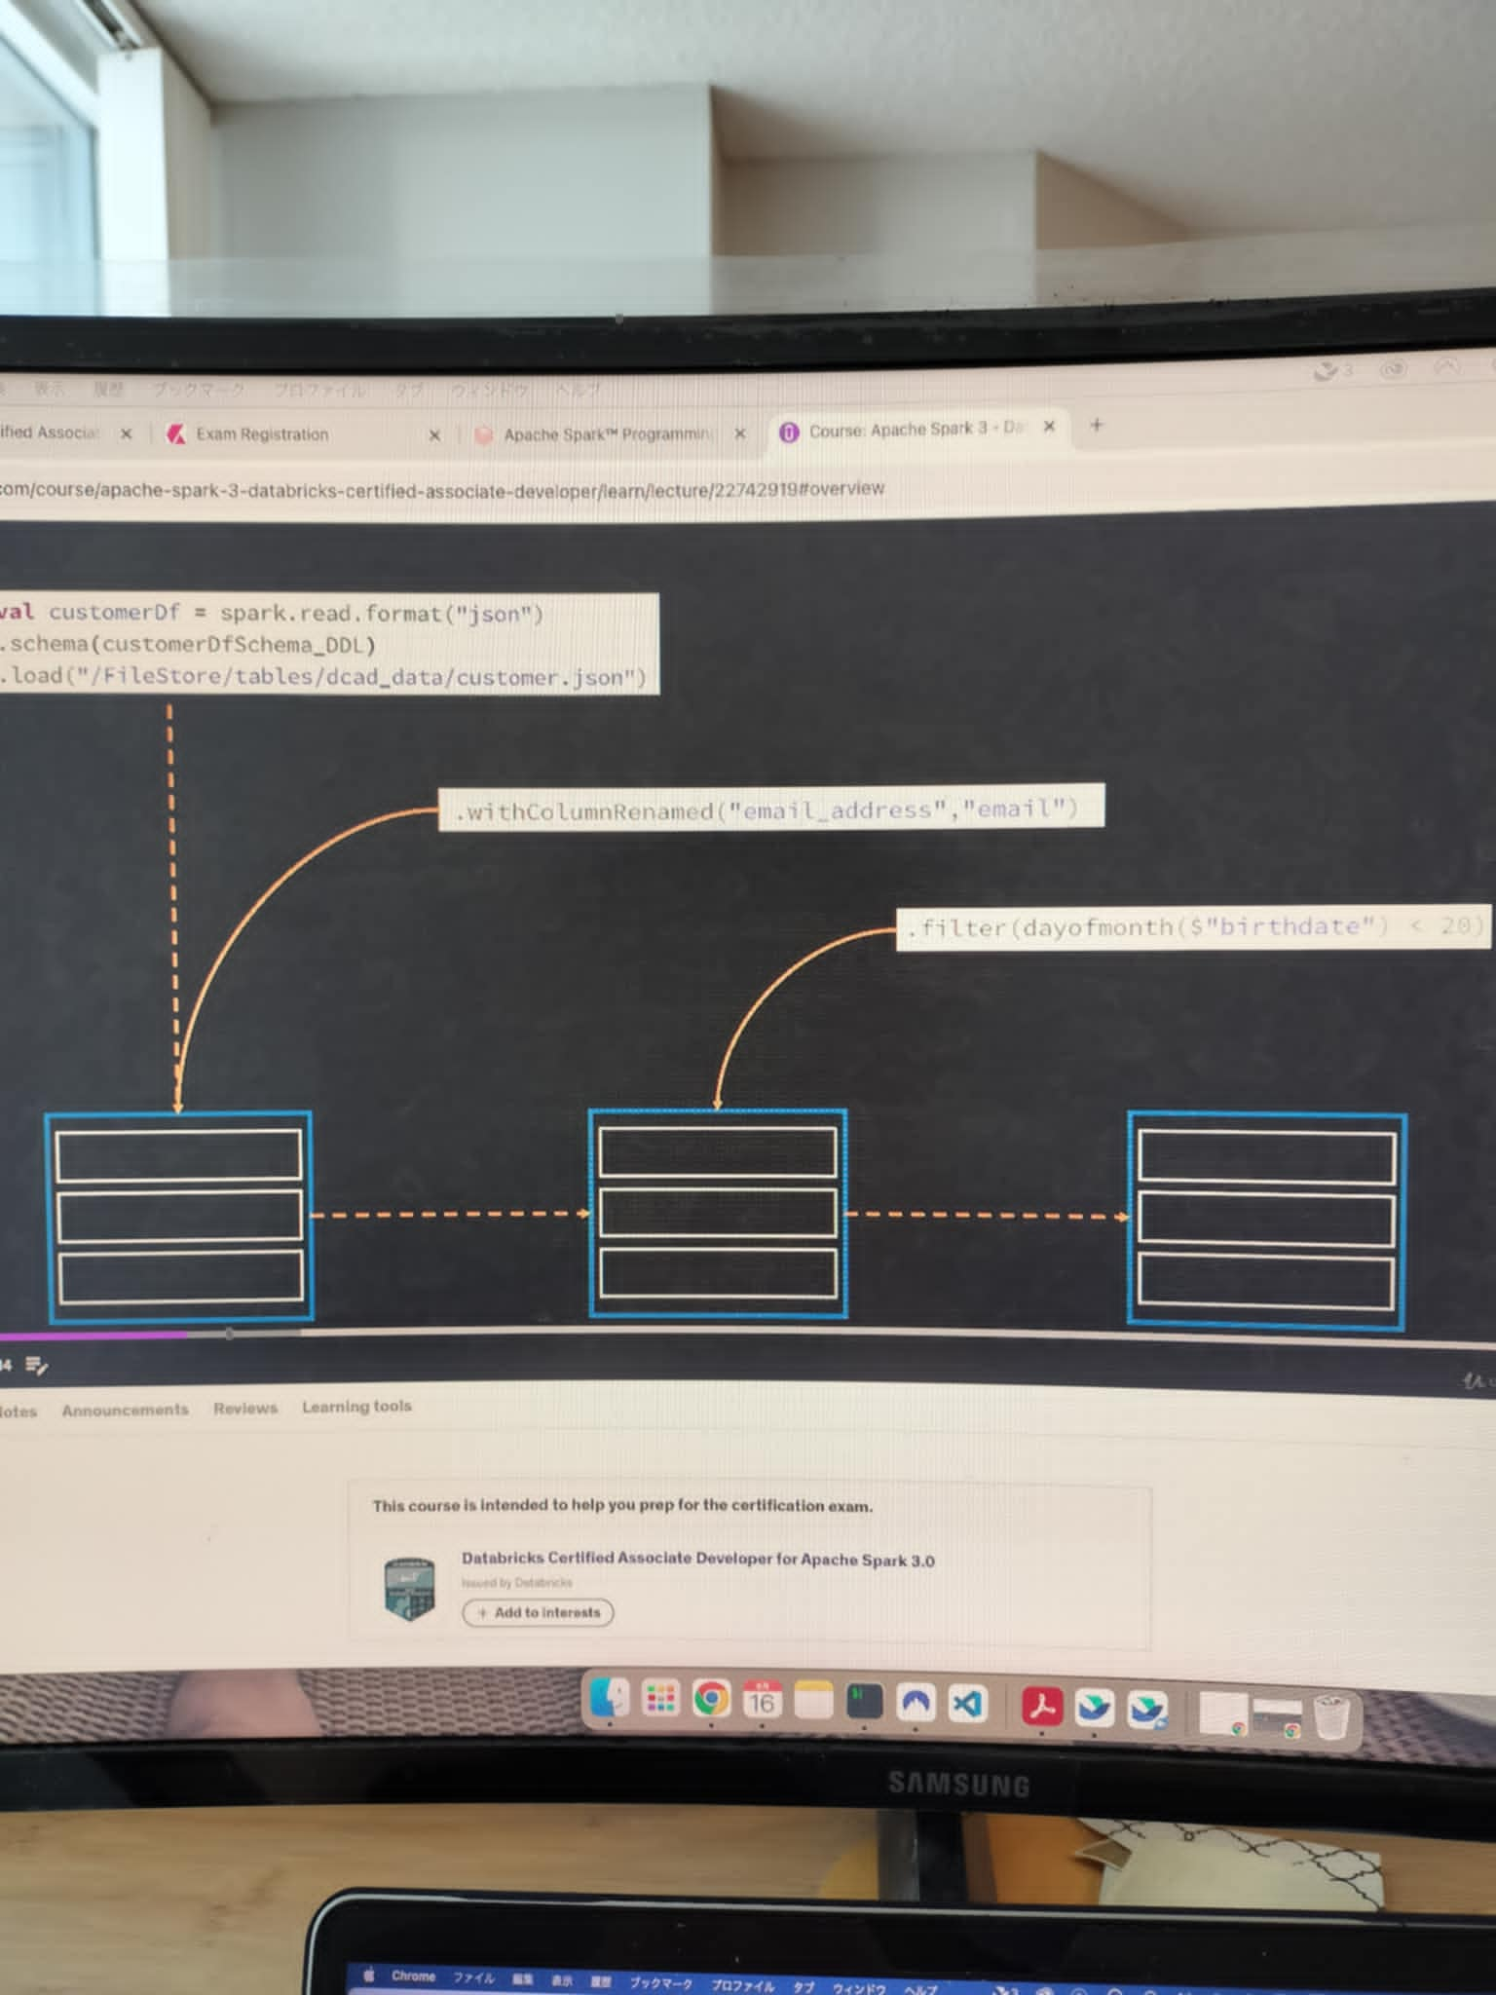

### Actions in dataframe

Action triggers the computation of all the transformation applied on a dataframe.

There are 3 types of actions

* 1.view data
* 2.collect data ex) take, collect, takeAsList
* 3.save data ex)save, saveAsTable

### 

### 

### 

### 

### Shuffling

Shuffling should be avoided whenever possible. But shuffling happens at the group by. This is because node needs to gather same key in the same node to calculate aggregation.

Shuffle can happen when you run

* Group by, order by
* Join
* Distinct
* Repartition/coalesce to resize a dataframe partition numbers.

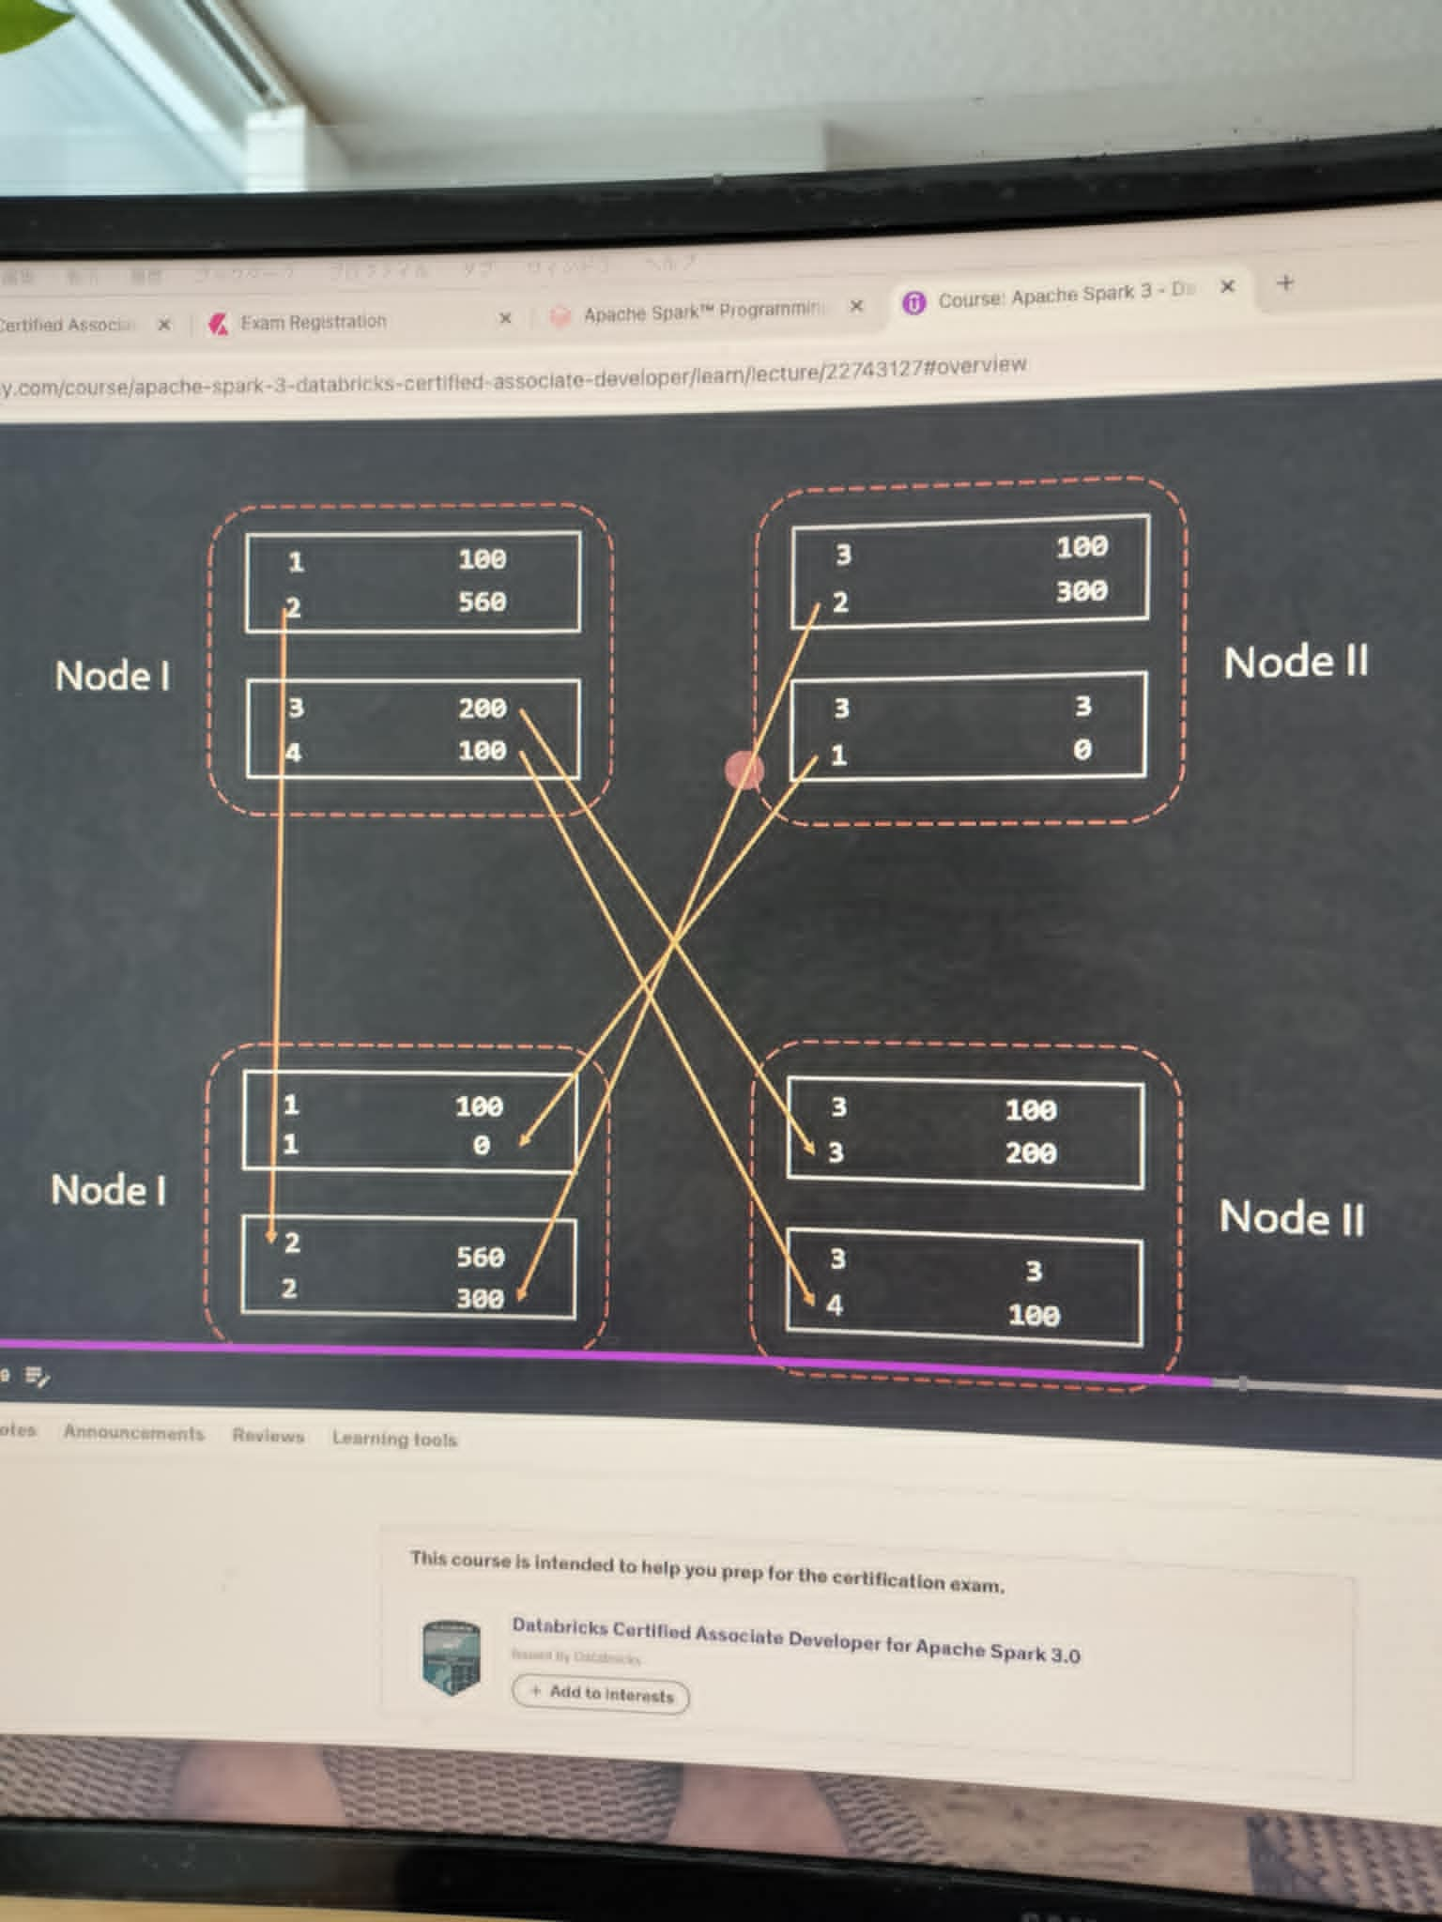

When keys in a partition in a dataframe are used in multiple partitions in the next dataframe, it’s called Wide Dependencies.

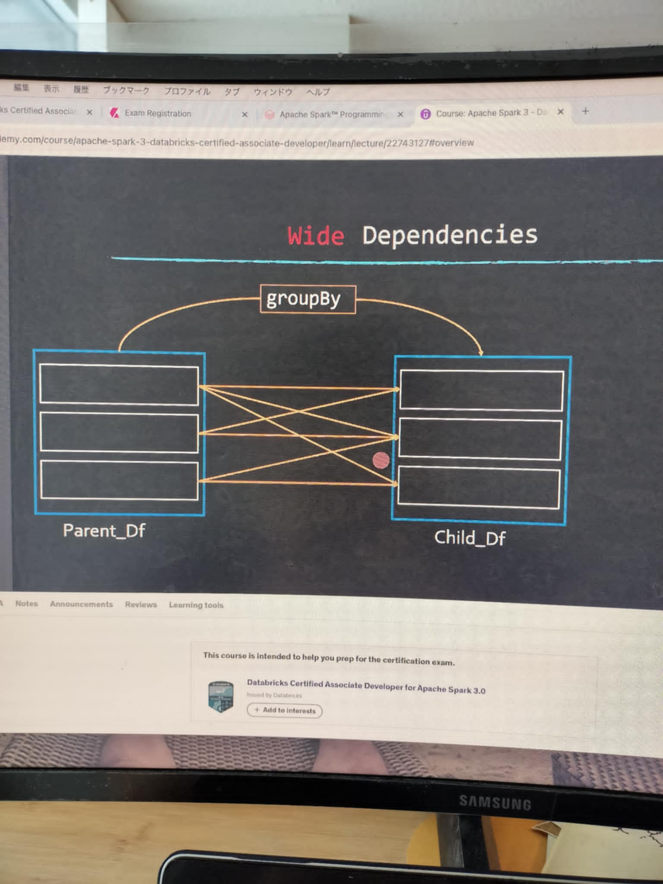

### How to avoid shuffle

* Avoidではないんだけど、partitionを小さくするのもoptimizationの一つ
  + ex) spark.conf.set(“spark.sql.shuffle.partitions”, 50)
  + Default is 50.
* Broadcast joinするとshuffleが避けられるのはなぜか。
  + Small dimension is assigned to every partition in a dataframe, so you don’t need to group the same key together anymore.

### DataFrame repartition vs partitionBy() vs coalesce()

* Repartitionでdataframe partitionはresizeされる。
  + If you want to change the file format you can:
    - ex) df.repartititon(8).write().format(“json”)
  + Note: you need to specify the mode() always.
    - ex) df.repartititon(8).write().mode(SaveMode.Overwrite)
* partitionBy(column_name: string)
  + repartitionがresizeが目的なのに対して、partitionBy()はpartition keyを変えることができる。
  + ex) df.repartititon(8).write().partitionBy(col(“example”)).format(“json”).mode(SaveMode.Overwrite).save()
* coalesce() changes the number of partitions in a single node. It will NOT trigger a shuffle.
* Repartition vs coalesce()
  + Both of them returns a new DF.
  + Repartition requires SHUFFLE, but coalesce() does not.
  + This is the result of df.show() after repartition. It has 4 stages.
  + 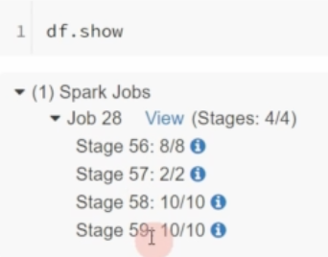
  + Coalesce is a narrow dependency, when one parent produces one child node.
    - ex) parent DF had 100 partitions in DF. child DF only has 10 DF, then each child partition came from 10 partitions in the parent DF.
  + Q: when do we prefer to use repartition() ? It seems coalesce() is always preferred as there is no shuffle.

### Query Planning

* High level planning flow
  + Stages are kind of partitioned worker. stage1がscanでstage2とかがexchange/shuffleをする。scanは一つのtaskができるので、number of tasksが少ない。逆にshuffleではmany tasksがDFの中でpartitionされるので、number of tasks(= partition)が増える。
  + 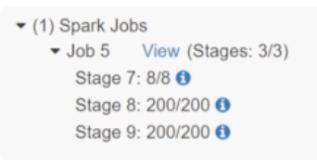
    - だとしたら、serializeしないといけないのでは? Dependencyがあるから。動画見るとやっぱりserializeされてるっぽい。でもstageの中でtask distributionできる。
  + Number of stages depend on the number of shuffle necessary.
  + Each stage consists of tasks. Number of tasks == number of cores in node CPU setting.
* 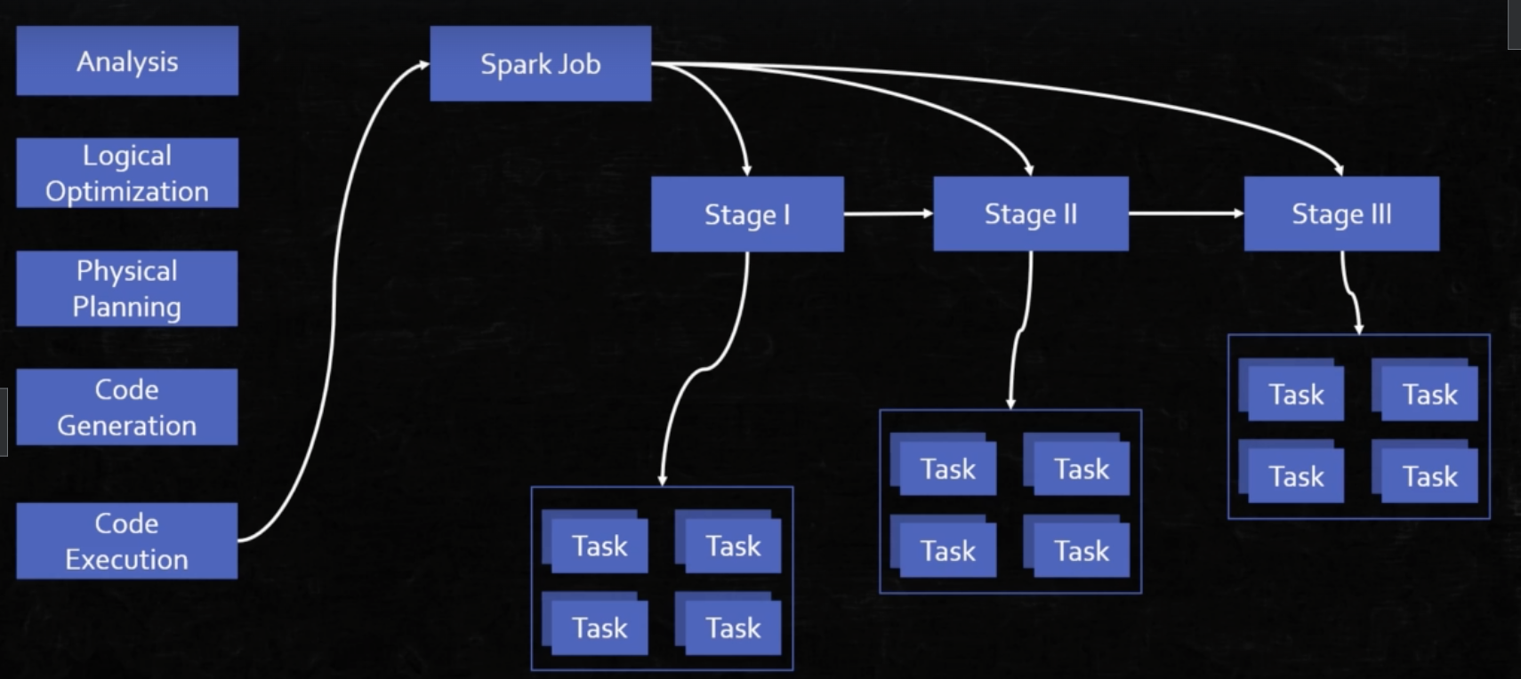
* To view the planning, run df.explain(True)
  + ここでいうexchangeはshuffleのこと
  + 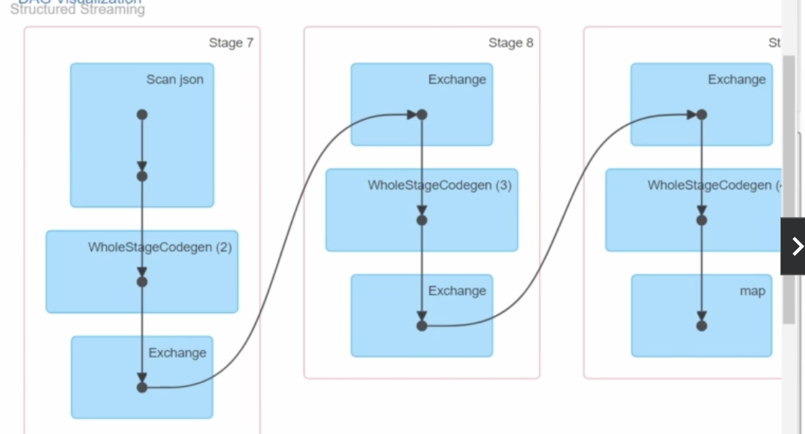
* To view the generated java code from python, run df.explain(“codegen”)

### Syntax in dataframe

* df.where(col(“col_A”).isNull) returns rows, but
* df.where(col(“col_A”) == null) returns **nothing**.
* Date/timestamp type
  + col(“unix_seconds”).cast(“Date”)
    - This does not work because you will miss unix_seconds ‘s seconds.
  + Instead, use col(“unix_seconds”).cast(“Timestamp”)
* df.outerJoin() caused an error, why?
  + There is not outerJoin()
  + Instead, run df.join(df_B, col(), “outer”)
* df.join (df_b, col, “cross”) caused an error, why?
  + df.crossjoin() should be used instead.
* What is the root cause of this error? df.write().path(filePath)
  + Error1: There is no path() function.
    - Correct way is df.write.json(filePath)
  + Error2: there is no write(). Use df.write.

### Serialization in Spark/Java

Javaのインスタンスをバイト配列として出力することをSerialize（シリアライズ）と言い、その逆をDeserializeと言います。

### Dataframe Partition in Spark

​​<https://learning.oreilly.com/videos/apache-spark-3/9781803241555/9781803241555-video3_6/>

よくある間違い

* partition = 10にした
* stage 0 はgroup by stage 1はgroup by のaggregation result.
* でも実際keyは5しかないから、5つのpartitionはあまる。
* solution: dynamic adaptive query = True by
  + spark.sql.adaptive.enabled = True
  + why? because 1) if partition size is small, then one partition gets too much data, which causes OOM in executors.
  + 2) If there are too many partitions, then input/output is inefficient which causes unexpected network issues.

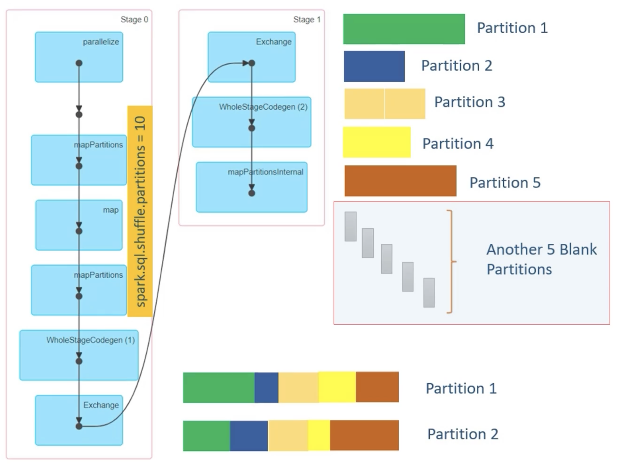

#### 大事なこと1: default partitionは間違っている

[Apache Spark Core—Deep Dive—Proper Optimization Daniel Tomes Databricks](https://www.youtube.com/watch?v=daXEp4HmS-E)

The default partition is 200. It often causes inefficiency.

**Right partition size = shuffle stage input data / target size**

and

**one partition size < 200 MB**

ex) if shuffle stage input = 210 GB

then

Right partition size = 210,000 MB / 200 MB = 1050 partitions.

**Moreover, if cluster has 2000 cores/slots, then** spark.sql.shuffle.partitions = 2000

で、このshuffle stage inputってのは、前のstageの、shuffle writeのこと。**一番右端。**

**この例ではstage19 has 45.4 GB, stage 20 has 8.6 GB so total 54GB**



#### 大事なこと1:Output partition [CoreとCompactionの関係]

insert writeとshuffleは同じstageによくいる。

例えばcluster executor coreが96あって、10しか使ってないと残りは無駄使い。

try coalesce() if it caused any problem.

### 

### Predicate push down and and partition pruning

* Predicate push down
  + filter from the read() phase
* **Partition pruning**
  + **Table scan is reduced if you use filtering based on partitions.**
* Dynamic partition pruning

### Memory in Spark

* By default. offHeap is disabled. You can enable it by spark.memory.offHeap.enabled = True

### Tuning in Spark

* Bad Example
  + number of executors=6
  + cores in each executor=16
  + memory for each executor=64g
* Good ex
  + number of executors=17
  + cores in each executor=5
  + memory for each executor=19gb

### Speculation

This will launch additional tasks with the same operation in an attempt to see whether it’s just some transient issue in the first task. Speculation is a powerful tool and works well with consistent file systems. However, it can cause duplicate data writes with some eventually consistent cloud services, such as Amazon S3, so check whether it is supported by the storage system connector you are using.

### How to deal with Slow Aggregations

* Increasing the number of partitions, prior to an aggregation, might help by reducing the number of different keys processed in each task.
* Increasing executor memory

### How Garbage Collection works

Try the G1GC garbage collector with -XX:+UseG1GC. It can improve performance in some situations in which garbage collection is a bottleneck.

<https://learning.oreilly.com/library/view/java-performance-2nd/9781492056102/ch05.html>

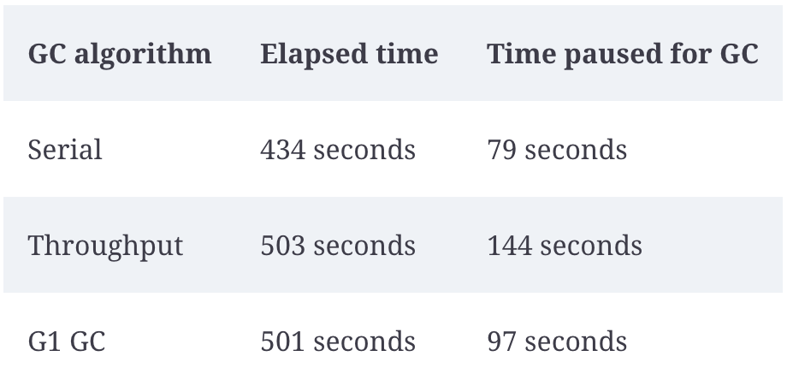

[Apache Spark Core—Deep Dive—Proper Optimization Daniel Tomes Databricks](https://www.youtube.com/watch?v=daXEp4HmS-E)

### Execution Plan

[Spark Execution Plans for Databricks](https://www.youtube.com/watch?v=O4MlLUYkjN8)

## Predicate pushdown using option(“basePath”, “bucket_name”)

[Lessons From the Field: Applying Best Practices to Your Apache Spark Applications - Silvio Fiorito](https://www.youtube.com/watch?v=iwQel6JHMpA)

### We all know that spark does not load dataframe into execution memory until action is called. But here we are seeing two jobs, why ?

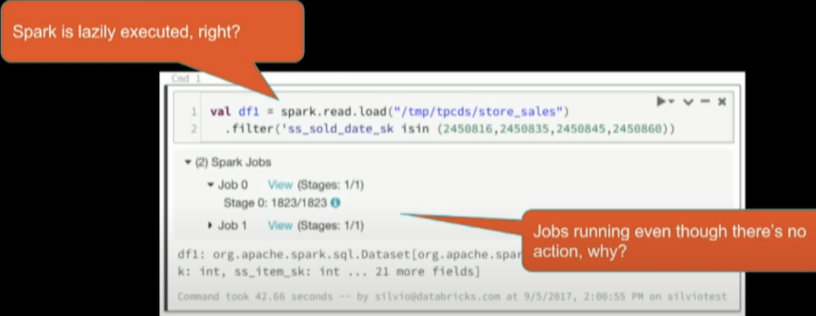

This is because datasource API maps spark.read.load into data source such as parquet and needs basic statistics for query planning in the background. So, this basic statistics **action** is called in the background.

### I used filter *sold_date_sk* in 4 days, but spark is loading more than 4 days, 1823 partitions. How can I reduce it to 4 days (partitions)?

#### option1: Use option

Spark indexes all partitions if you don’t use ***option(“basePath”, “bucket/”).load(“bucket/ds={ds}”)*** !!

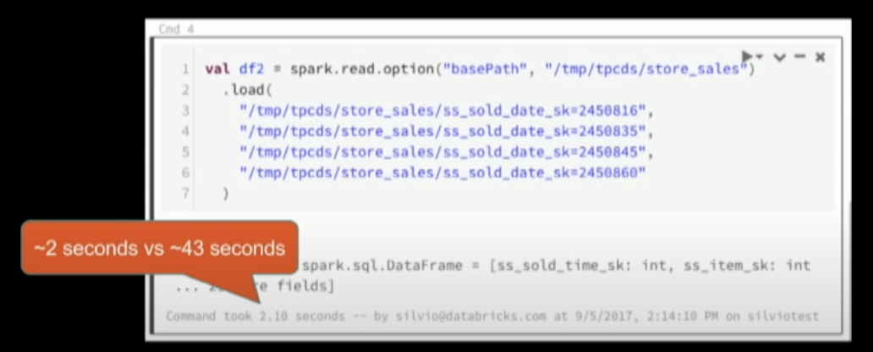

#### option2: Create external table in Hive metastore and use read.table (valid from Spark 2.1 +)

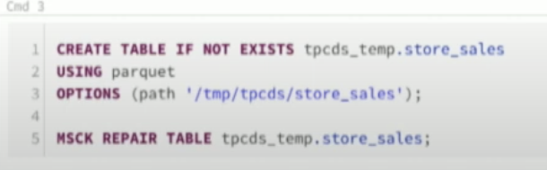

so if you create an external table in Hive, Spark read().table().filter(“ds” isin (“”,””, “”) ) will automatically apply a predicate pushdown.

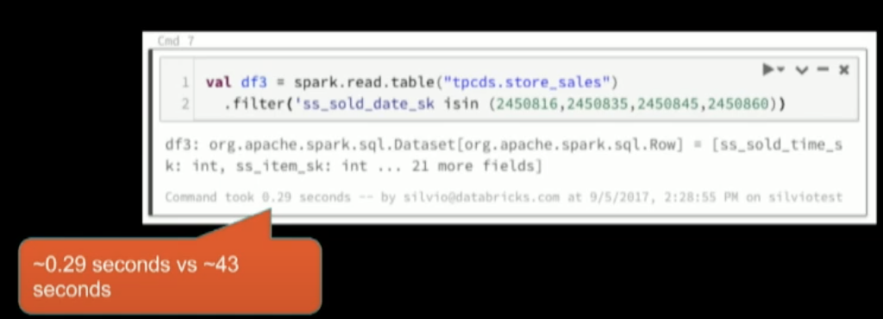

## Many small files problem

* option1: coalesce() at the insert stage
* option2: From Spark 2.2 - SET spark.sql.files.maxRecordsPerFile
  + What is this? Usually one partition writes to one file. This defines Spark keeps writing until it hits max records. To avoid concurrent write, this is NOT parallelized, so it can introduce additional latency.
    - There is an option to parallelize, with repartition with additional key, but it can be risky.
  + default is disabled.
  + Use this if option1 encounters an error of “one partition is too large size.”

## Managed (Internal) Table vs External Table

[Lessons From the Field: Applying Best Practices to Your Apache Spark Applications - Silvio Fiorito](https://www.youtube.com/watch?v=iwQel6JHMpA)

### External Table Example

Notice you define your **path in OPTIONS**



In Dataframe API

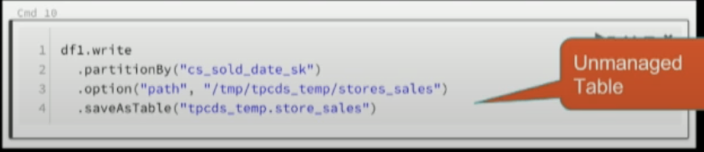

### Managed (Internal) Table Example

**Notice you DON’T define OPTIONS nor path**

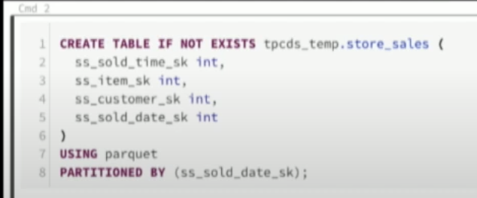

In Dataframe API

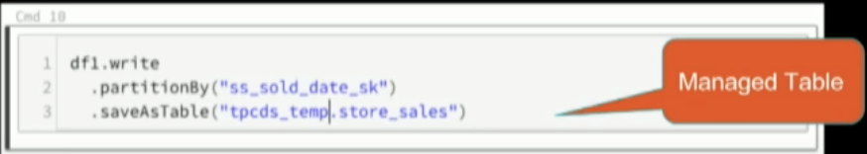

### Which one should I use?

If you use Managed table, DELETE statement will physically delete the file itself.

## Schema Inference in CSV

Don’t use option(“inferSchema”, true) for every file!

Instead,

* option1: Use managed (internal) table
* option2: if it’s external tables, then only option(“inferSchema”, true) for the first file, and then use the schema definition in the .schema(definition)
  + See GOOD example.

Summary from [Lessons From the Field: Applying Best Practices to Your Apache Spark Applications - Silvio Fiorito](https://www.youtube.com/watch?v=iwQel6JHMpA):

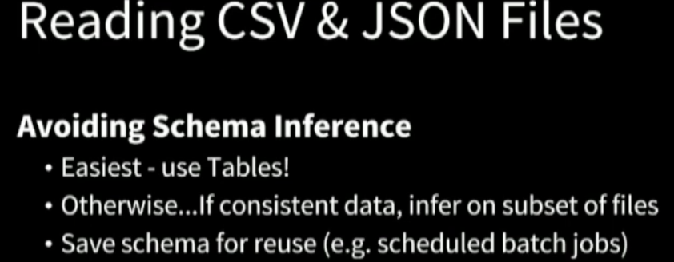

**BAD)**

This example took 48 sec.

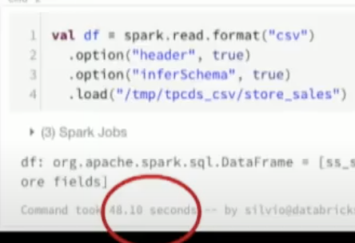

**GOOD)**

This example took 6 sec.

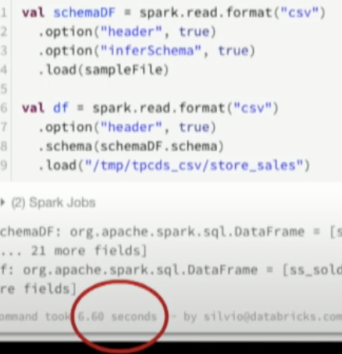

## Adaptive Query Execution (AQE)

[Spark Execution Plans for Databricks](https://www.youtube.com/watch?v=O4MlLUYkjN8)

Spark is smart enough to optimize query planning at runtime.

spark.conf.set(“spark.sql.adaptive.enabled”, “true”)

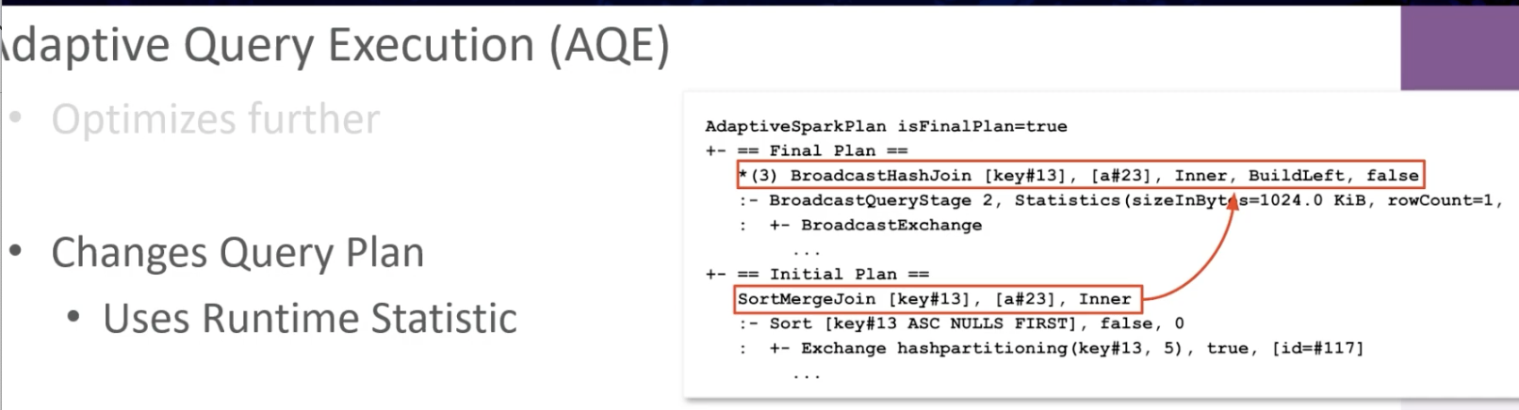

This is visible from Spark UI.

## Join Hints and Partition Hints

[Spark Execution Plans for Databricks](https://www.youtube.com/watch?v=O4MlLUYkjN8)

SQL itself does not guarantee anything. In this case, Spark chooses a JOIN strategy based on default threshold unless specified.

With hints, Spark can listen to your instructions.

### In Dataframe

You just specify join strategy such as

df1.join(broadcast(df2), df1.colA = df2.colA, “inner”)

### In SQL

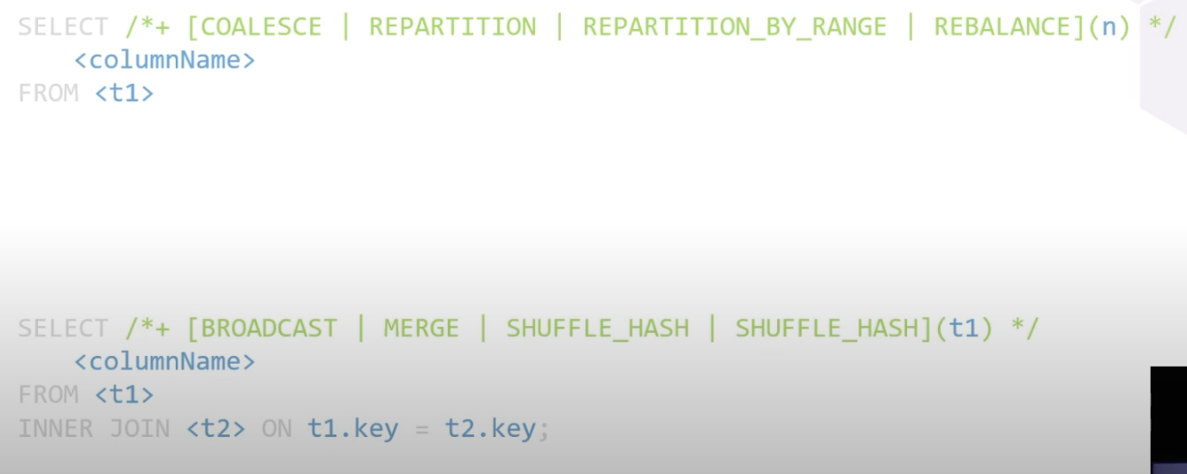

## SQL Hints for small files issue by using COALESCE()

Good example of using distribute by in SQL

<https://spark.apache.org/docs/latest/sql-ref-syntax-qry-select-distribute-by.html#examples>

There are two options to reduce the number of partitions

option1: use hints [**Hints - Spark 3.5.1 Documentation**](https://spark.apache.org/docs/latest/sql-ref-syntax-qry-select-hints.html#partitioning-hints)

ex)

select /*+ REPARTITION(200) */ *

from table

option2: Use distribute by and let dynamic query engine reduce the partition number

set spark.sql.shuffle.partitions=10240;

insert overwrite table schema.table_name partition (partition='20241215')

select /* Reduce partitions to 200 for final write */

*

from table

distribute by rand() % 200;

### FAQ: What happens if I enabled spark.sql.adaptive.enabled=true; but did not set set spark.sql.adaptive.coalescePartitions.enabled=true; ? Will adaptive engine still optimize output partition size ?

If you enable **spark.sql.adaptive.enabled=true** but do **not** explicitly set **spark.sql.adaptive.coalescePartitions.enabled=true**, the behavior depends on Spark's default configuration settings

**spark.sql.adaptive.coalescePartitions.enabled is true by default**:

* In Spark 3.0 and later versions, the default value for **spark.sql.adaptive.coalescePartitions.enabled** is **true**.
* This means that even if you do not explicitly set it, Spark will automatically coalesce small shuffle partitions to optimize the output partition size, as part of Adaptive Query Execution (AQE).
* The dynamic adjustment of partitions ensures efficient query execution and output file management.

How does AQE determine the partition size?

When true and spark.sql.adaptive.enabled is true, Spark will coalesce contiguous shuffle partitions according to the target size (specified by **spark.sql.adaptive.advisoryPartitionSizeInBytes**), to avoid too many small tasks.

[Performance Tuning - Spark 3.5.3 Documentation](https://spark.apache.org/docs/latest/sql-performance-tuning.html#coalescing-post-shuffle-partitions)

### hints vs distribute by

distribute by rand() % 200 adds shuffling partition column, so insert takes time.

So hints would be generally better.

# 3.Spark UI/Explain

You can use the explain command in many ways!!

[Spark Execution Plans for Databricks](https://www.youtube.com/watch?v=O4MlLUYkjN8)

### In PySpark

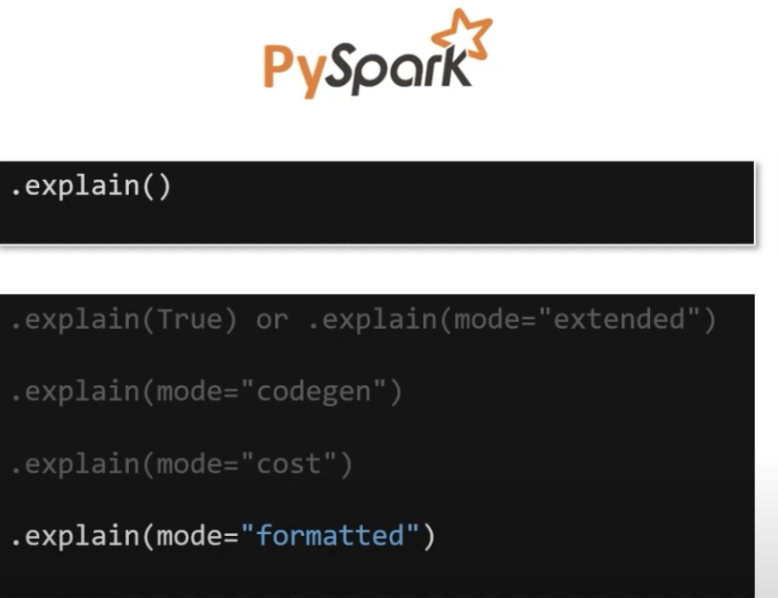

df.explain()

df.explain(“formatted”)

df.explain(“codegen”)

df.explain(“cost”)

df.explain(“extend”)

### In SQL

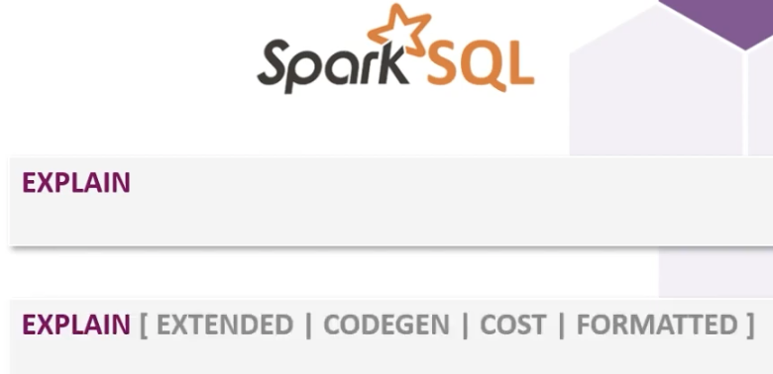

# 4.Hadoop

## 4-1.MapReduce

map() -> shuffle -> reduce()

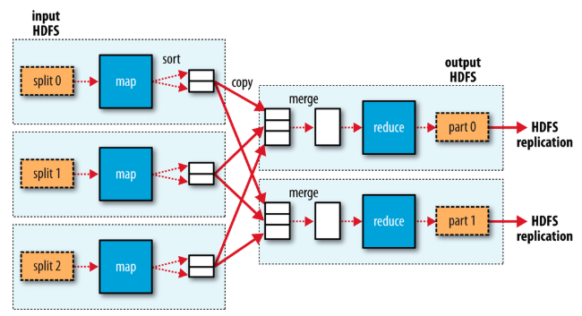

* Each map() in a split (=partition) is a for loop.
* shuffle groups data by key into a partition0, 1,...
* Then, reduce() will find max(), sum(), .etc.

## 4-2. HDFS

Read

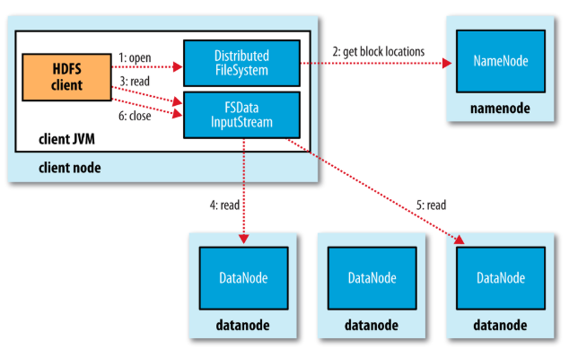

Write

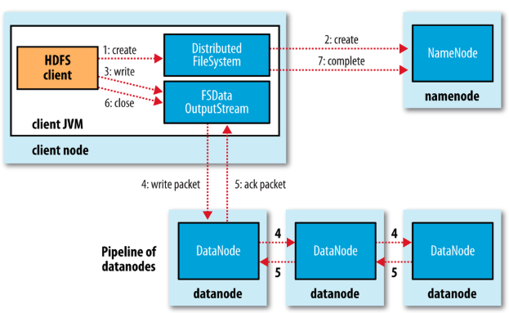

# 5.Yarn

<https://learning.oreilly.com/library/view/hadoop-the-definitive/9781491901687/ch04.html>

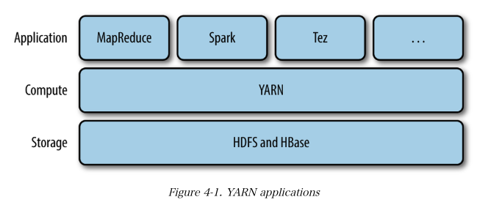

## MapReduce vs YARN

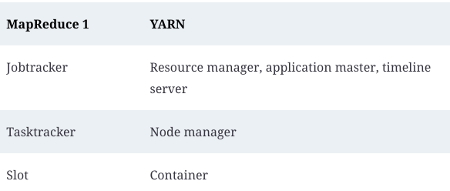

## YARN architecture

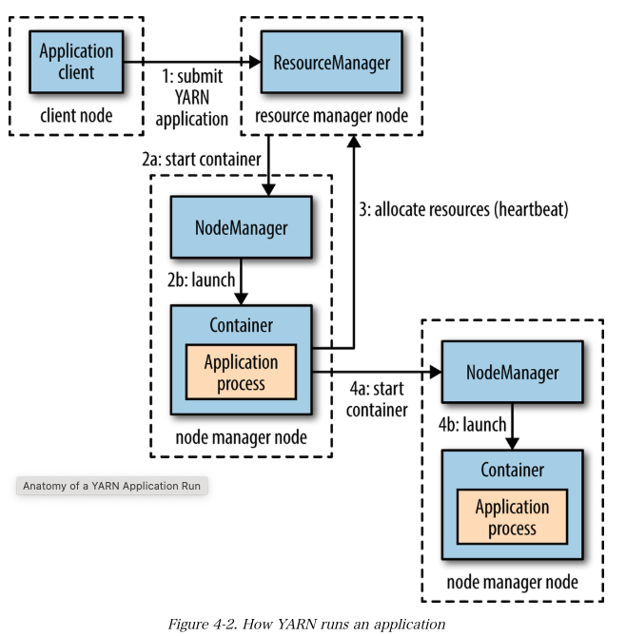

Now, let's show how Spark runs on YARN

<https://learning.oreilly.com/library/view/hadoop-the-definitive/9781491901687/ch19.html#ExecutorsAndClusterManagers>

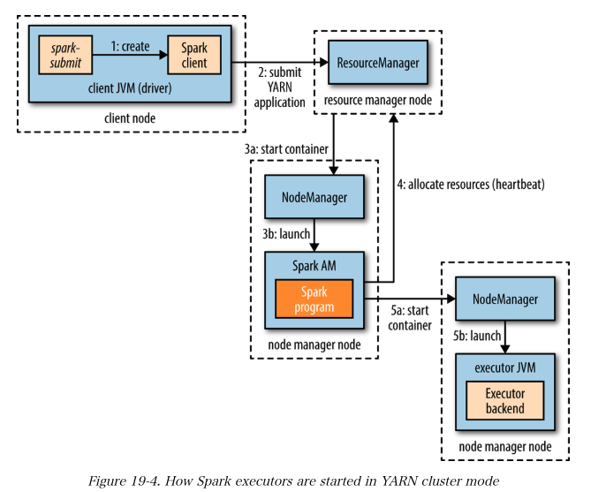

## YARN Scheduler

これめっちゃいい

[YARN キュー の基本：3つの種類（FIFO, Capacity, Fair）をメリデメとともに図解 - Qiita](https://qiita.com/IQ_Bocchi/items/1561f32af51073d8d0e8)

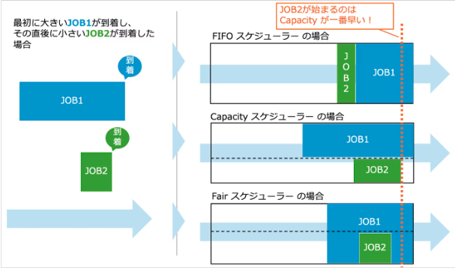

* Capacity スケジューラーのデメリットは、大きく分けて２つあります。
  + 空いているキャパシティが無駄になる
  + 割り当てられたキューの容量を必ずしもすぐに使えないケースがある
* 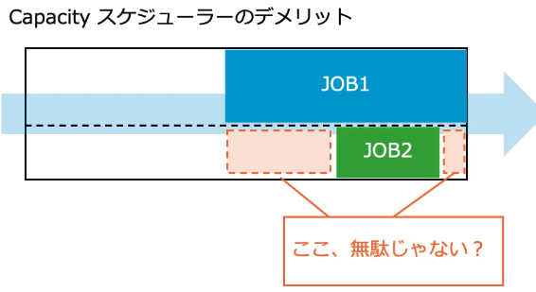
* Fair スケジューラーのデメリット
  + Fair スケジューラーの注意点は、JOBの処理中はキューが常にフルで使われることになるため、割り込みのJOBが資源の割り当てをもらえるまで一定の待ち時間が発生することです。
  + 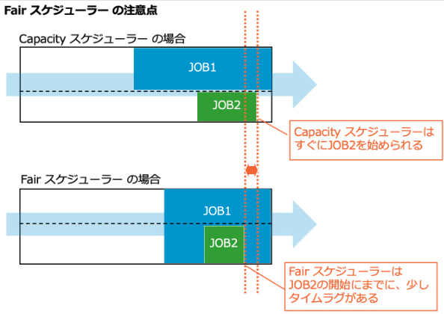
  + これにより、もしも Capacityスケジューラーで常に一定の割合を空けておけばすぐに開始できたはずのJOBが、Fairスケジューラーの場合は一定時間待たないと開始できない、ということが起こり得ます。

# 

# 8.Common Errors & Pain points

# 9.Exam questions

* Is Spark driver fault tolerant ? What happens if it fails?
* No, the Spark driver is not fault-tolerant. If the Spark driver fails, the entire application will crash. Here's what happens if the Spark driver fails
* Spark does not have built-in mechanisms for automatic driver recovery. While executors can fail and be retried, a driver failure typically requires manual intervention to restart the application unless external systems are involved.
* What is spark driver?
  + Ans: Spark driver is the program space where the Spark’s main method runs. ✅coordinating the Spark entire application.
* What is the relationship between node and executor?
  + An executor is a process running on a node.
* explain the difference between slots and tasks in Spark, and explain why spark job will not run efficiently if the number of slots is higher than the one of tasks.
  + **Slots (=physical hardware work unit)** represent the available capacity for parallel execution on the executors. Each executor has a fixed number of slots, which is typically determined by how many cores or threads it has.
  + **Tasks (=logical work unit)** represent the smallest units of work that are distributed across executors for parallel processing.
  + Relationship: A **task is executed in a slot**. A Spark job is divided into stages, and within each stage, there are multiple tasks corresponding to partitions of data.
  + Therefore, if number of slots > number of tasks, that means there exists some idle slots.
  + なので、Node >> Executor >> Slot (hardware limit, CPU) >> Task (logical work unit)
* In your words, what is lazy evaluation?
  + A process is lazily evaluated if its execution does NOT start until it is put into action by some trigger.
* How do we define data frame partition in Spark? What is the default setting?
  + Default Partitioning (Based on Input Source)
    - When you read data from a file or a data source like HDFS, S3, or a database, Spark automatically partitions the data based on the input source.
    - For example, when reading from HDFS or S3, Spark partitions the DataFrame based on the block size of the file (usually 128 MB or 256 MB). Each block is loaded as a partition.
  + Using repartition()
  + You can manually repartition a DataFrame using the repartition() function. This function allows you to increase or decrease the number of partitions.
    - val df = spark.read.csv("data.csv")
    - val repartitionedDF = df.repartition(10) // Repartition into 10 partitions
  + If I want to partition DF into 12 where DF is already partitioned by 8, do you use df.repartition(12) or df.coalesce(12)?
    - repartition(12) because coalesce can only reduce the number.
  + Suppose you have a function assess() and let’s say you want to run it on each row. Which option is correct?
    - Option1: [assess(row) for row in df.collect() ]
    - Option2: [assess(row) for row in df ]
  + If I want to store data in a dataframe into Spark's memory only, then should I use cache() or persist() ? If I understand correctly, cache() cached data into memory and disk. But I want to store it only in memory.
    - If you want to store your DataFrame only in memory, you need to use: persist(StorageLevel.MEMORY_ONLY).
  + Does union() shuffle data ?
    - No.s
* What’s wrong with this?
  + df.wrte.partitionBy(col(“col_A”)).path(file_path)
    - partitionBy does not require col()
  + df.write.option(“parquet”).partitionBy(“col_A”).path(file_path)
    - Option never has parquet format.
      * まず、.path()なんてないぞ。
      * df.write.partitionBy(“col_A”).parquet(file_path)が正解
  + df.duplicates().drop()
    - Duplicatesなんてないぞ。
    - 正しくはdf.dropDuplicates()
  + ds.withColumn(“col_A”, substr(col(“col_B”) , 0 , 2 ))
    - substr() なんてないぞ。col(“col_B”).substr(0, 2)が正解。
* めちゃいい問題。
  + 